

**Boston University**

**Electrical & Computer Engineering**

**EC464 Capstone Senior Design Project**

User's Manual



Submitted to

Brandon Miller

Philips

222 Jacob St

Cambridge, MA 02141

585-267-9130

Brandon.Miller@philips.com

by

Team 24

E-Remote: Inclusive Video Game Controller

Team Members

Seok Young Choi [email1@bu.edu](mailto:email1@bu.edu)

Nicholas Gutierrez [email2@bu.edu](mailto:email1@bu.edu)

Eunhye Kwon [ekwon23@bu.edu](mailto:ekwon23@bu.edu)

Lisa Wei [ylisawei@bu.edu](mailto:ylisawei@bu.edu)

Submitted: April 17, 2023

#### E-Remote User’s Manual

#### Table of Contents

**Executive Summary 3**

**1 Introduction 4**

**2 System Overview and Installation 6**

2.1 Overview block diagram 6

2.2 Physical description. 6

2.3 Installation, setup, and support 9

**3 Operation of the Project 13**

3.1 Operating Mode 1: Normal Operation 13

3.2 Operating Mode 2: Abnormal Operations 13

3.3 Safety Issues 14

**4 Technical Background 15**

4.1 Hardware Overview 15

**5 Relevant Engineering Standards 21**

**6 Cost Breakdown 22**

**7 Appendices 23**

7.1 Appendix A - Specifications 23

7.2 Appendix B – Team Information 24

# 

# 

# 

# 

# 

# 

# 

# Executive Summary

E-Remote

Team 24

Although gaming communities create a space where people from all over the world can meet, joining the community is not as easy as switching the ON button. The barriers of entry are prevalent, especially for those with physical disabilities. The purpose of this project is to lower that barrier.

E-Remote is an inclusive video game controller designed specifically to fit the needs of individuals with hand arthritis. Not only did we keep our users in mind, but we allowed gamers with hand arthritis to be a part of our physical design process!

Our product is a fully functional video game controller, compatible with PC through Bluetooth connectivity with innovative features such as palm-controllable joysticks and touch sensor buttons. The controller should have full functionality with at least four different genres of video games: arcade, puzzle, racing, and shooting. The user should play with minimal to no pain reported after 30 minutes.

These features will eliminate problems of conventional video game controllers and provide a fun and comfortable gaming experience. A controller rated E – for Everyone!

# Introduction

In recent years, online connectivity has become increasingly important for people to share experiences, with video games being a popular way to connect with others online. However, the handheld controllers required for most games can pose a barrier to entry for individuals with physical disabilities, such as hand arthritis, which is the most common physical disability faced by gamers, representing 14% of the disabled gaming community. The standard controllers and some existing inclusive controllers are not designed to fit the needs of individuals with hand arthritis and can cause unnecessary pain with small and intricate movements, repetitive motions, and heavy weight.

To increase accessibility in the gaming community, we propose the E-Remote, an inclusive video game controller designed to address these issues. Our product is specifically designed for individuals with hand arthritis and provides a fun and intuitive gaming experience. According to research, 20.5% of the gaming community comprises individuals with disabilities who are more engaged with purchasing adjacent gaming content, such as add-ons and subscriptions, than their able-bodied counterparts.

E-Remote is a revolutionary new video game controller that is designed to be inclusive, portable, and compatible with a range of popular video games. With its specialized hardware and intuitive design, this controller offers a range of benefits that are not available with traditional controllers. Some key features of E-Remote are palm controllable joysticks and touch sensor buttons. E-Remote also eliminates the weight problem that can make traditional controllers uncomfortable to use for long periods of time as users will not have to hold the controller when using it.

E-Remote is powered by a Lithium Ion Polymer Battery (3.7V, 500mAh), which provides up to 24 hours of battery life. The microcontroller used is an ESP32 feather board, which provides a powerful and reliable platform for controlling the controller's functions. Additionally, the controller features an MPR121 board that allows for 12 capacitive touch sensor inputs, making it easy to control the game without having to use standard buttons. The Slow Fade Programmed LEDs, with potentiometer slider to control the brightness, provide a unique visual experience that enhances the gaming experience. This design not only creates a relaxed hand position but also eliminates the pain caused by small and intricate movements. The E-Remote is also designed to be intuitive, allowing players to fully understand the controller after just five minutes of use. And with a price point of under $99.99, this controller is the most affordable option on the market. Whether you're a casual gamer or a serious player, the E-Remote is the perfect choice for anyone who wants to enjoy a more inclusive and comfortable gaming experience.

In the following sections, we will provide a more detailed overview of the E-Remote system, including its hardware and software components, installation process, and operating instructions. We will also delve into the technical background of the product, including relevant engineering standards and specifications. Additionally, we will provide a cost breakdown of the materials and labor required to develop and produce the E-Remote, as well as any potential future costs for maintenance and upgrades. By the end of this manual, you should have a comprehensive understanding of how the E-Remote works, how to use it, and what it takes to create an accessible and inclusive product for the gaming community.

# System Overview and Installation

## Overview block diagram

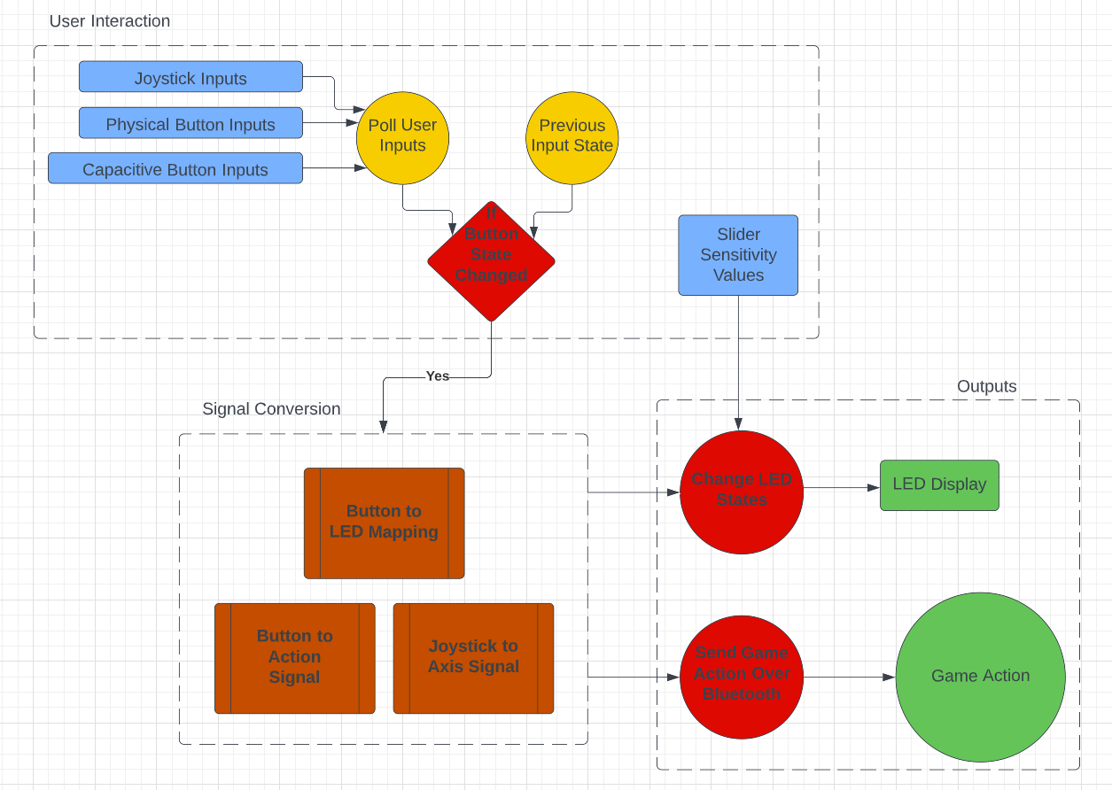

*Figure 2.1: System Overview of the E-Remote.*

## Physical description.

Provide a sketch of your project hardware (accurate and to scale, in 3-D or as a series of planar views), or photograph.

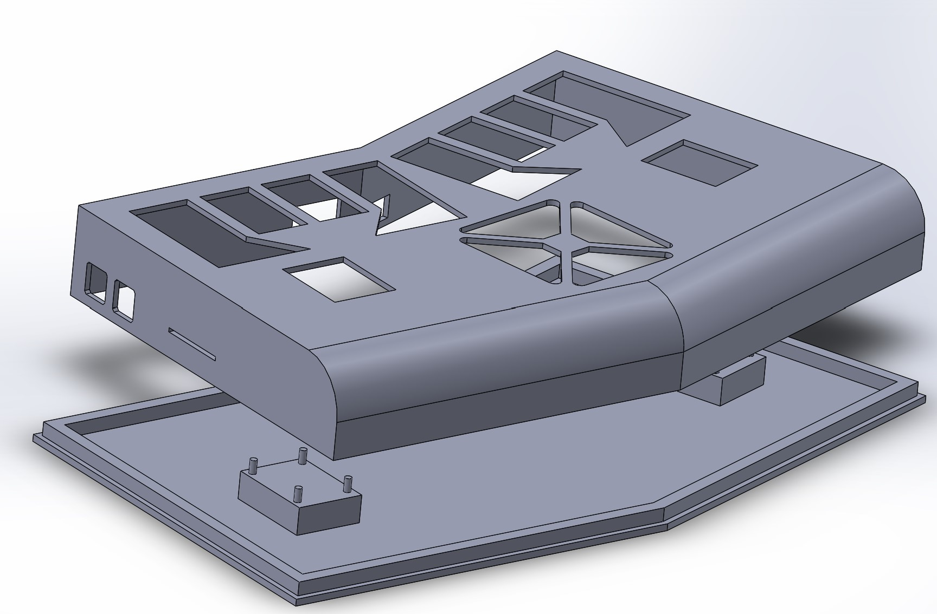

*Figure 2.2.1: 3D Modeling of the Casing*

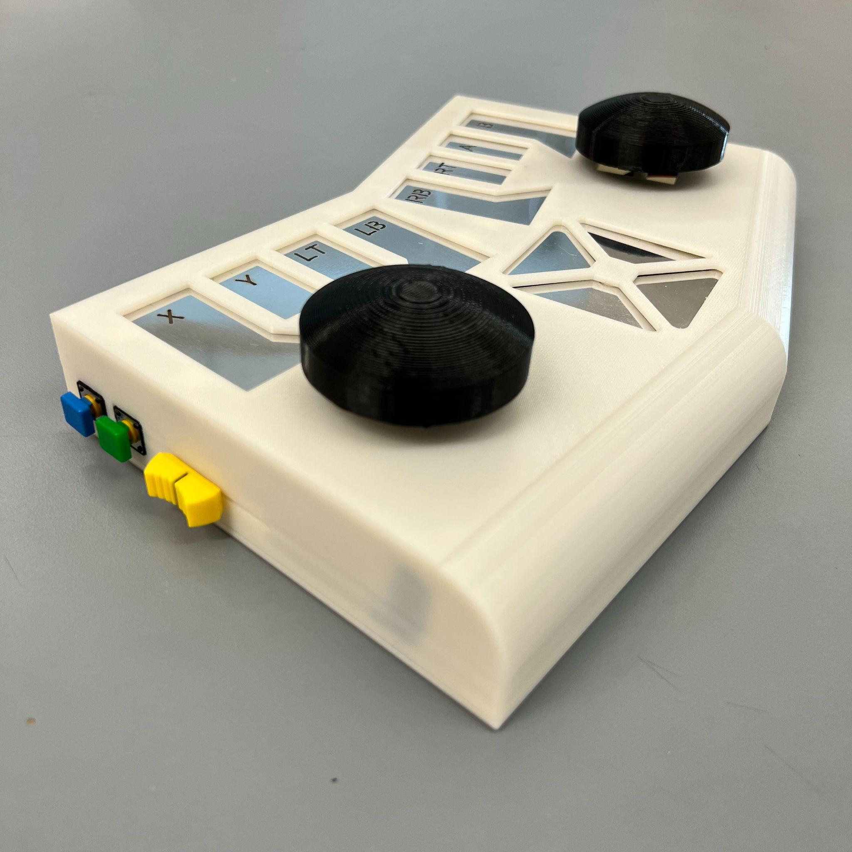

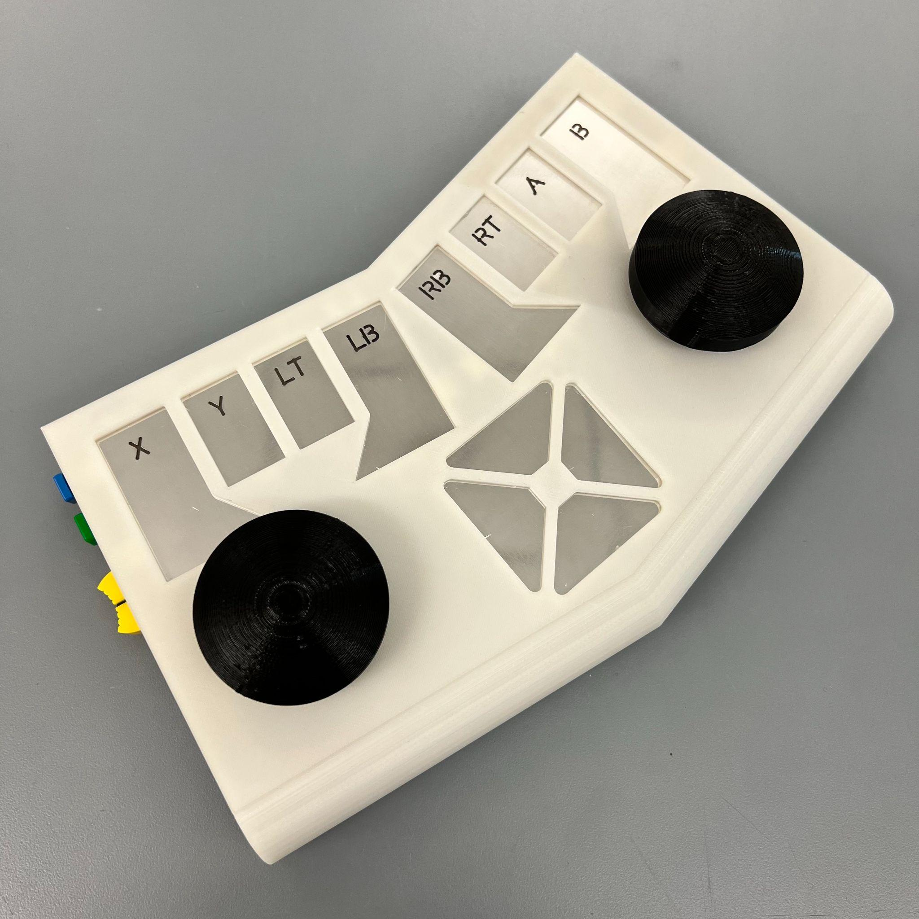

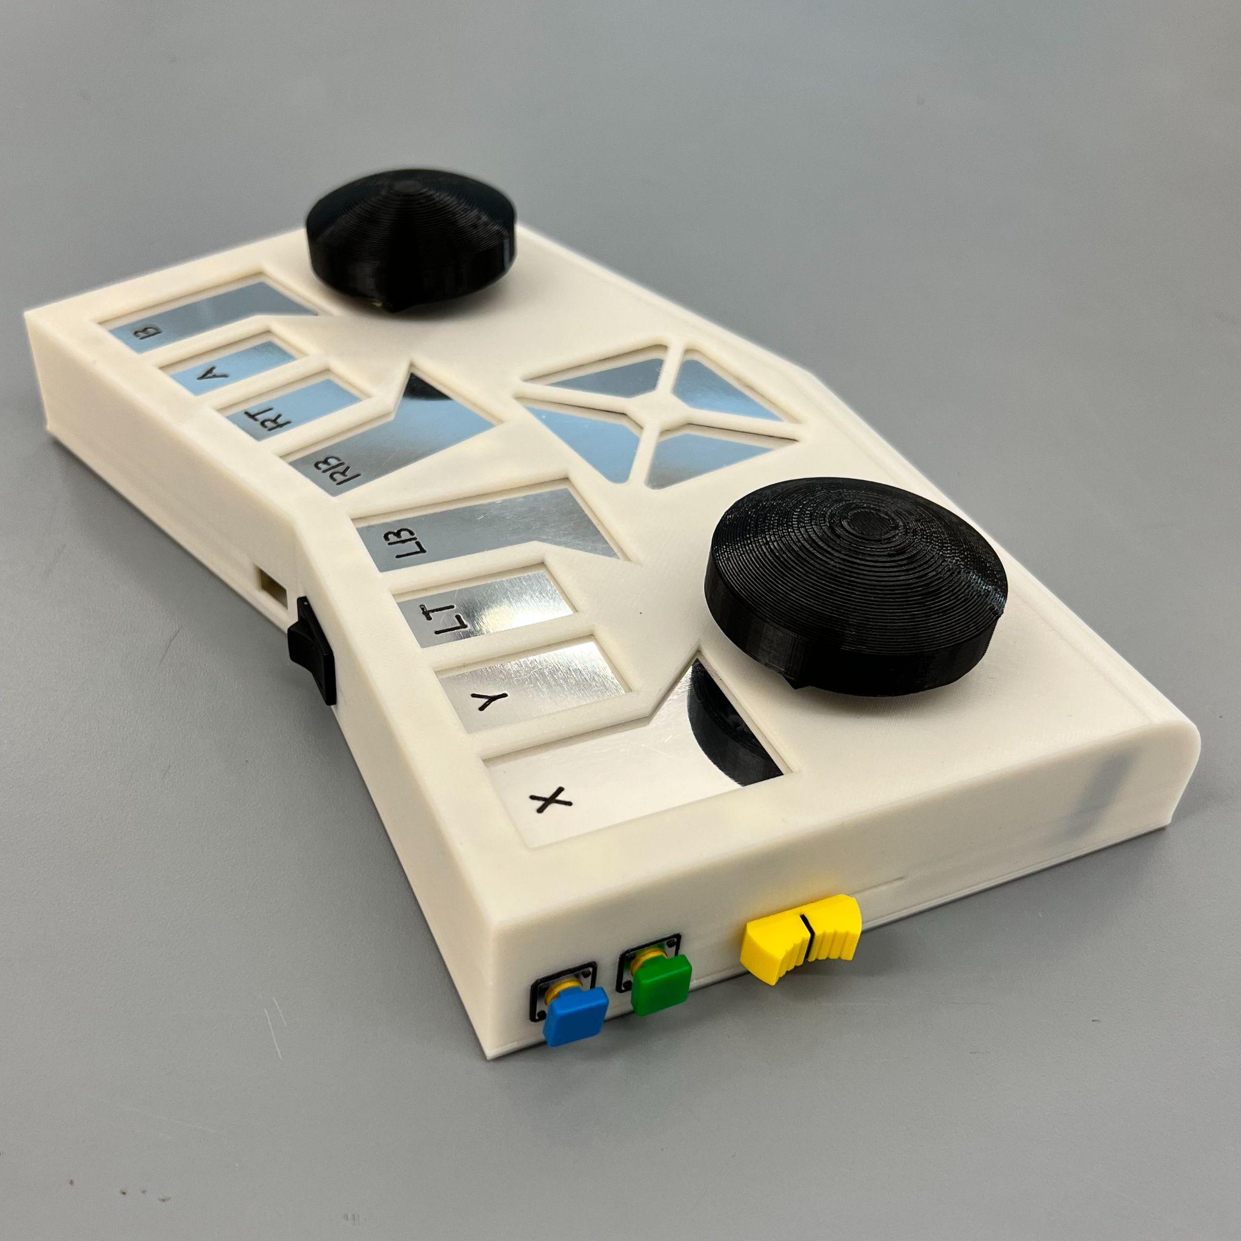

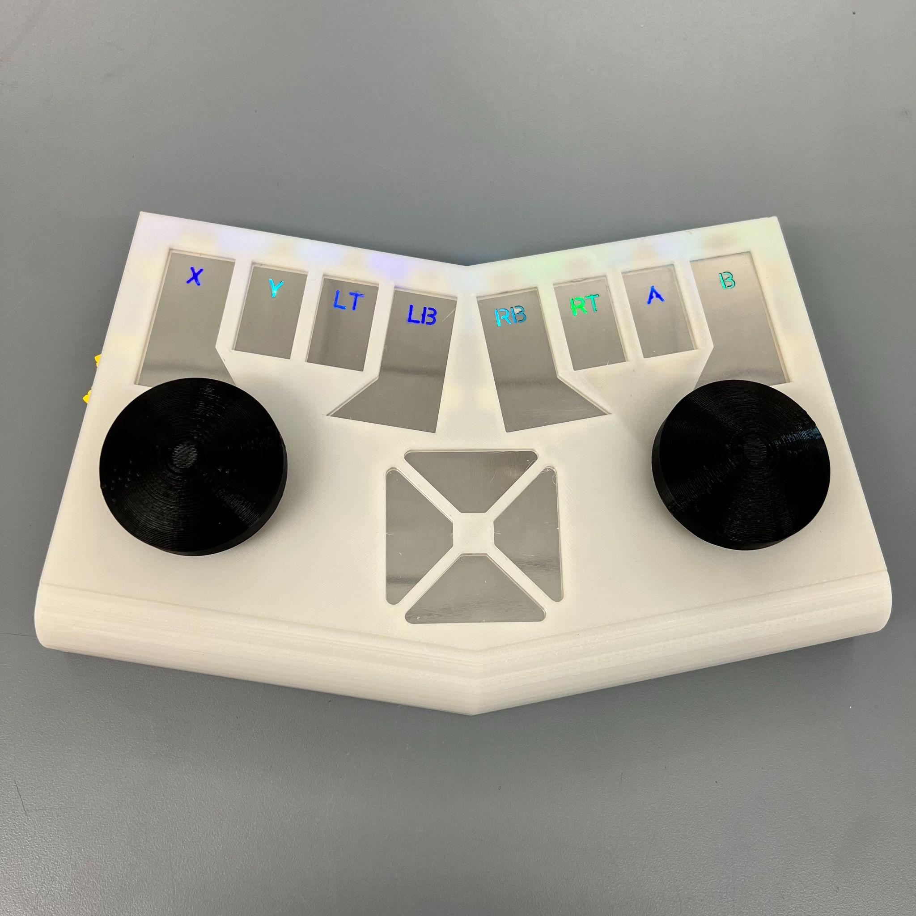

## Installation, setup, and support

Connecting the Device

1. Flip the power switch located on the right side of the device. You should see an indicator LED light up when properly turned on.
2. Open your computer’s Bluetooth menu and search for new device
   1. Windows: type “Bluetooth” in the search bar and it will be the first option
   2. Mac: Apple menu -> System Settings -> Bluetooth
3. Wait for E-Remote to appear, select it, and wait for the device to connect
4. Open any form of gamepad testing software. We recommend <https://gamepad-tester.com/> as it provides an intuitive GUI, but built-in testers like the Windows Setup USB Gamepad program also work
5. Check that all the inputs are working properly. Each button press should have a corresponding indicator in the tester light-up. When checking the joysticks, you should see four total axes in operation (in <https://gamepad-tester.com/> this is Axis 0 and 1 for the left and 2 and 5 for the right)
   1. Note that there should be 15 total buttons listed, 3 physical and 12 touch
6. If no indicator lights up when a button is pressed or a joystick is moved, the see Abnormal Operations section below. Otherwise, move on to the next section.

Connecting to the Game

Note: These instructions will be for the Steam game library which you can install at <https://store.steampowered.com/about/>. While we do not provide instructions for any other game library, E-Remote is registered as a generic gamepad by computers and instructions can be found for generic gamepad setup for other libraries.

1. If not already installed, install Steam, set up an account, and install your first game
2. Open Steam and open big picture mode. The symbol is in the top right corner, a box with two arrows in opposite corners.

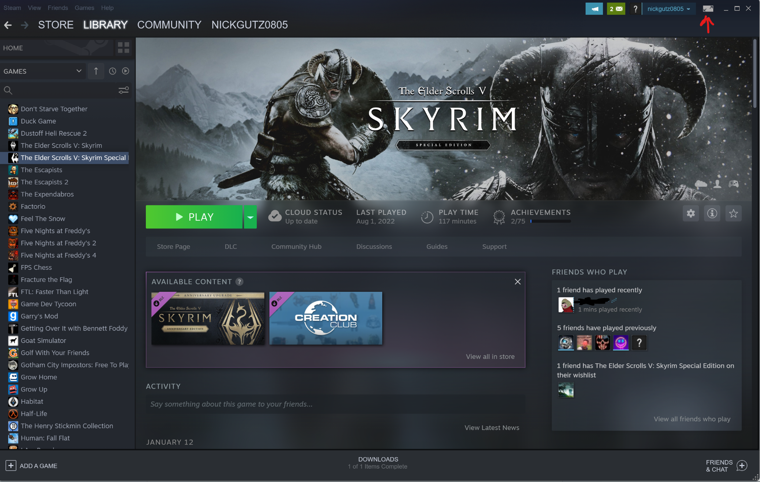

*Figure 2.2: Location of the Big Picture Mode button in Steam (Top right corner of the Steam Desktop App)*

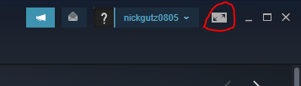

*Figure 2.3: Zoom in on Big Picture Mode button*

1. In Big Picture Mode, open settings by Menu in the bottom left corner then click Settings.

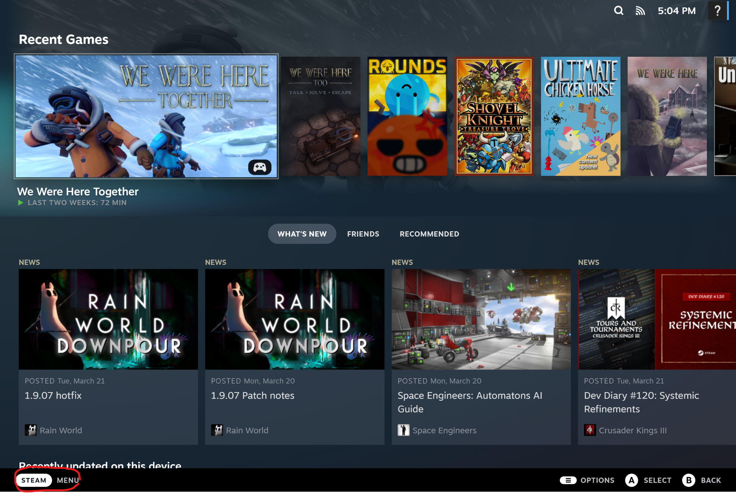

*Figure 2.4:Location of the Menu button in Big Picture Mode (Bottom Left corner)*

1. At the top of the page, you will see Setup Input Devices. click Begin Setup to start setting up your controls.
2. Next, you will be defining your controls. The program will walk you through the buttons you need to set. The recommended layout is labeled on the controller but you are free to set them however you wish.
   1. If you would like to verify your controls are working in Steam, the same Big Picture Mode Controller Settings has a Test Device Input menu

. 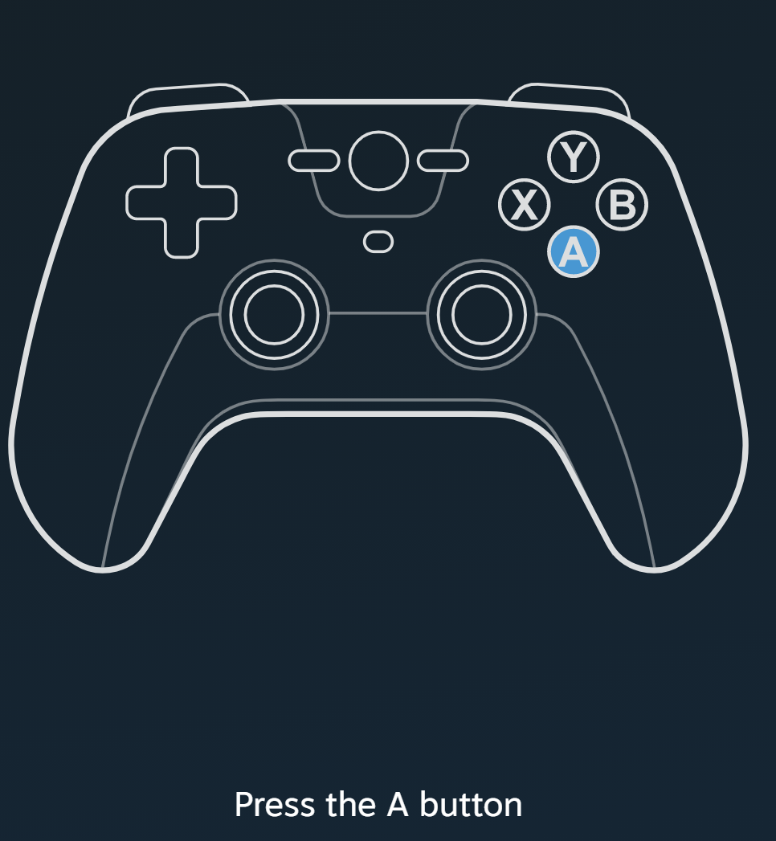

*Figure 2.5: Control Mapping Walkthrough in Big Picture Mode*

1. Once your configuration is saved, you should be able to open any game and play with your controller. See Section 3 for further details
   1. If you want to exit Big Picture Mode, go to Menu in the bottom left and click Power -> Exit Big Picture Mode. You are not required to be in Big Picture Mode to use your controller

# Operation of the Project

## Operating Mode 1: Normal Operation

Powering on the E-Remote

To turn on the E-Remote, simply flip the power switch located on the back of the device or connect a Micro USB to the power port. LEDs should light up indicating the device has started properly.

Features of the E-Remote

The E-Remote comes with several accessibility features to make your gaming experience more enjoyable including

1. 12 Capacitive touch buttons labeled X, Y, RT, RB, LB, LT, A, B, and a four-way Directional Pad. These buttons do not require a hard press to activate, instead responding with a tap. These buttons also adjust to your play style, automatically adjusting to the intensity of your tap
2. LEDs that power on with the device and cycle through colors
3. A slider located on the left side of the device will adjust the brightness of the LEDs ranging from off to full brightness
4. A rechargeable Lithium Polymer (LiPoly) battery

Playing In Game

If you followed the setup instructions in **Section 2.3** properly then you should be able to open any game in Steam and play using your E-Remote provided the game has controller support. If you open the game and nothing happens when you use the controller, see Game Not Reading controls in **Section 3.2**.

Charging E-Remote

E-Remote comes with a removable LiPoly battery that has up to two days of battery life. This battery can be recharged by plugging a Micro USB into the charging port found on the back of the device next to the power switch. Charging should take approximately 5 hours. **Keep the device ON when charging.**

Although the device can be powered on solely through the charging cord, the battery still needs to be powered on when plugged in to recharge properly. While you can play while the battery is charging, do note that this will damage the battery's health over time.

## Operating Mode 2: Abnormal Operations

Game Not Reading Controls

1. Go to your Bluetooth menu and verify that your controller is connected. It should say Connected and not Paired
2. Go to the program you used to test your controls in **Section 2.3** (such as <https://gamepad-tester.com/>). Verify all your controls are working.
3. In Steam, go to the Steam tab in the top left corner and go to settings. Go to Controller -> General Controller settings. This will open up a secondary menu. Make sure that you can see your controller detected under all the checkboxes. The default name is 4 Axis 10 Button Gamepad with Hat Switch
4. Enable Steam Input
   1. Enter Big Picture Mode
   2. Select the game you want to play
   3. Click on the controller icon to enter the Controller Settings
   4. In the Controller Settings, click the gear symbol
   5. Click Enable Steam Input

Touch Buttons Not Working

First, turn the device off and on. Sometimes, the wires get jostled during play and require a device restart to get reconnected.

If that does not help, make sure you have not been resting your fingers or other objects on the buttons in between playing. Since the controller automatically adjusts to your style of touch, prolonged resting on the buttons will skew the readings and disable the touch. To fix this, simply let the device run with nothing resting on the buttons, the sensitivity should readjust after a minute or two.

## Safety Issues

* E-Remote comes with a rechargeable LiPoly battery. It is important to note that Lithium-based batteries are only allowed in a carry-on when flying due to concern over damaged batteries overheating and catching on fire. Make sure to have your E-Remote powered off and safely stored in a backpack for the duration of your flight.
* Do Not leave your device charging overnight for similar concerns of overheating and combustion. Maximum charge time is five hours
* E-Remote is not water resistant so please keep any containers containing water far away from the device to prevent any damage to yourself or the E-Remote..

# Technical Background

## Hardware Overview

E-Remote uses an Adafruit HUZZAH32 (ESP32 Feather board) microcontroller to control the overall system by taking in all user inputs and translating them into the correct signals needed by the PC to register a game action. The ESP32 feather board was chosen for its embedded ESP32-WROOM-32E chip, which enables Bluetooth capabilities, allowing the controller to wirelessly connect to any PC with Bluetooth support and for its built-in Lithium Ion Polymer charger. 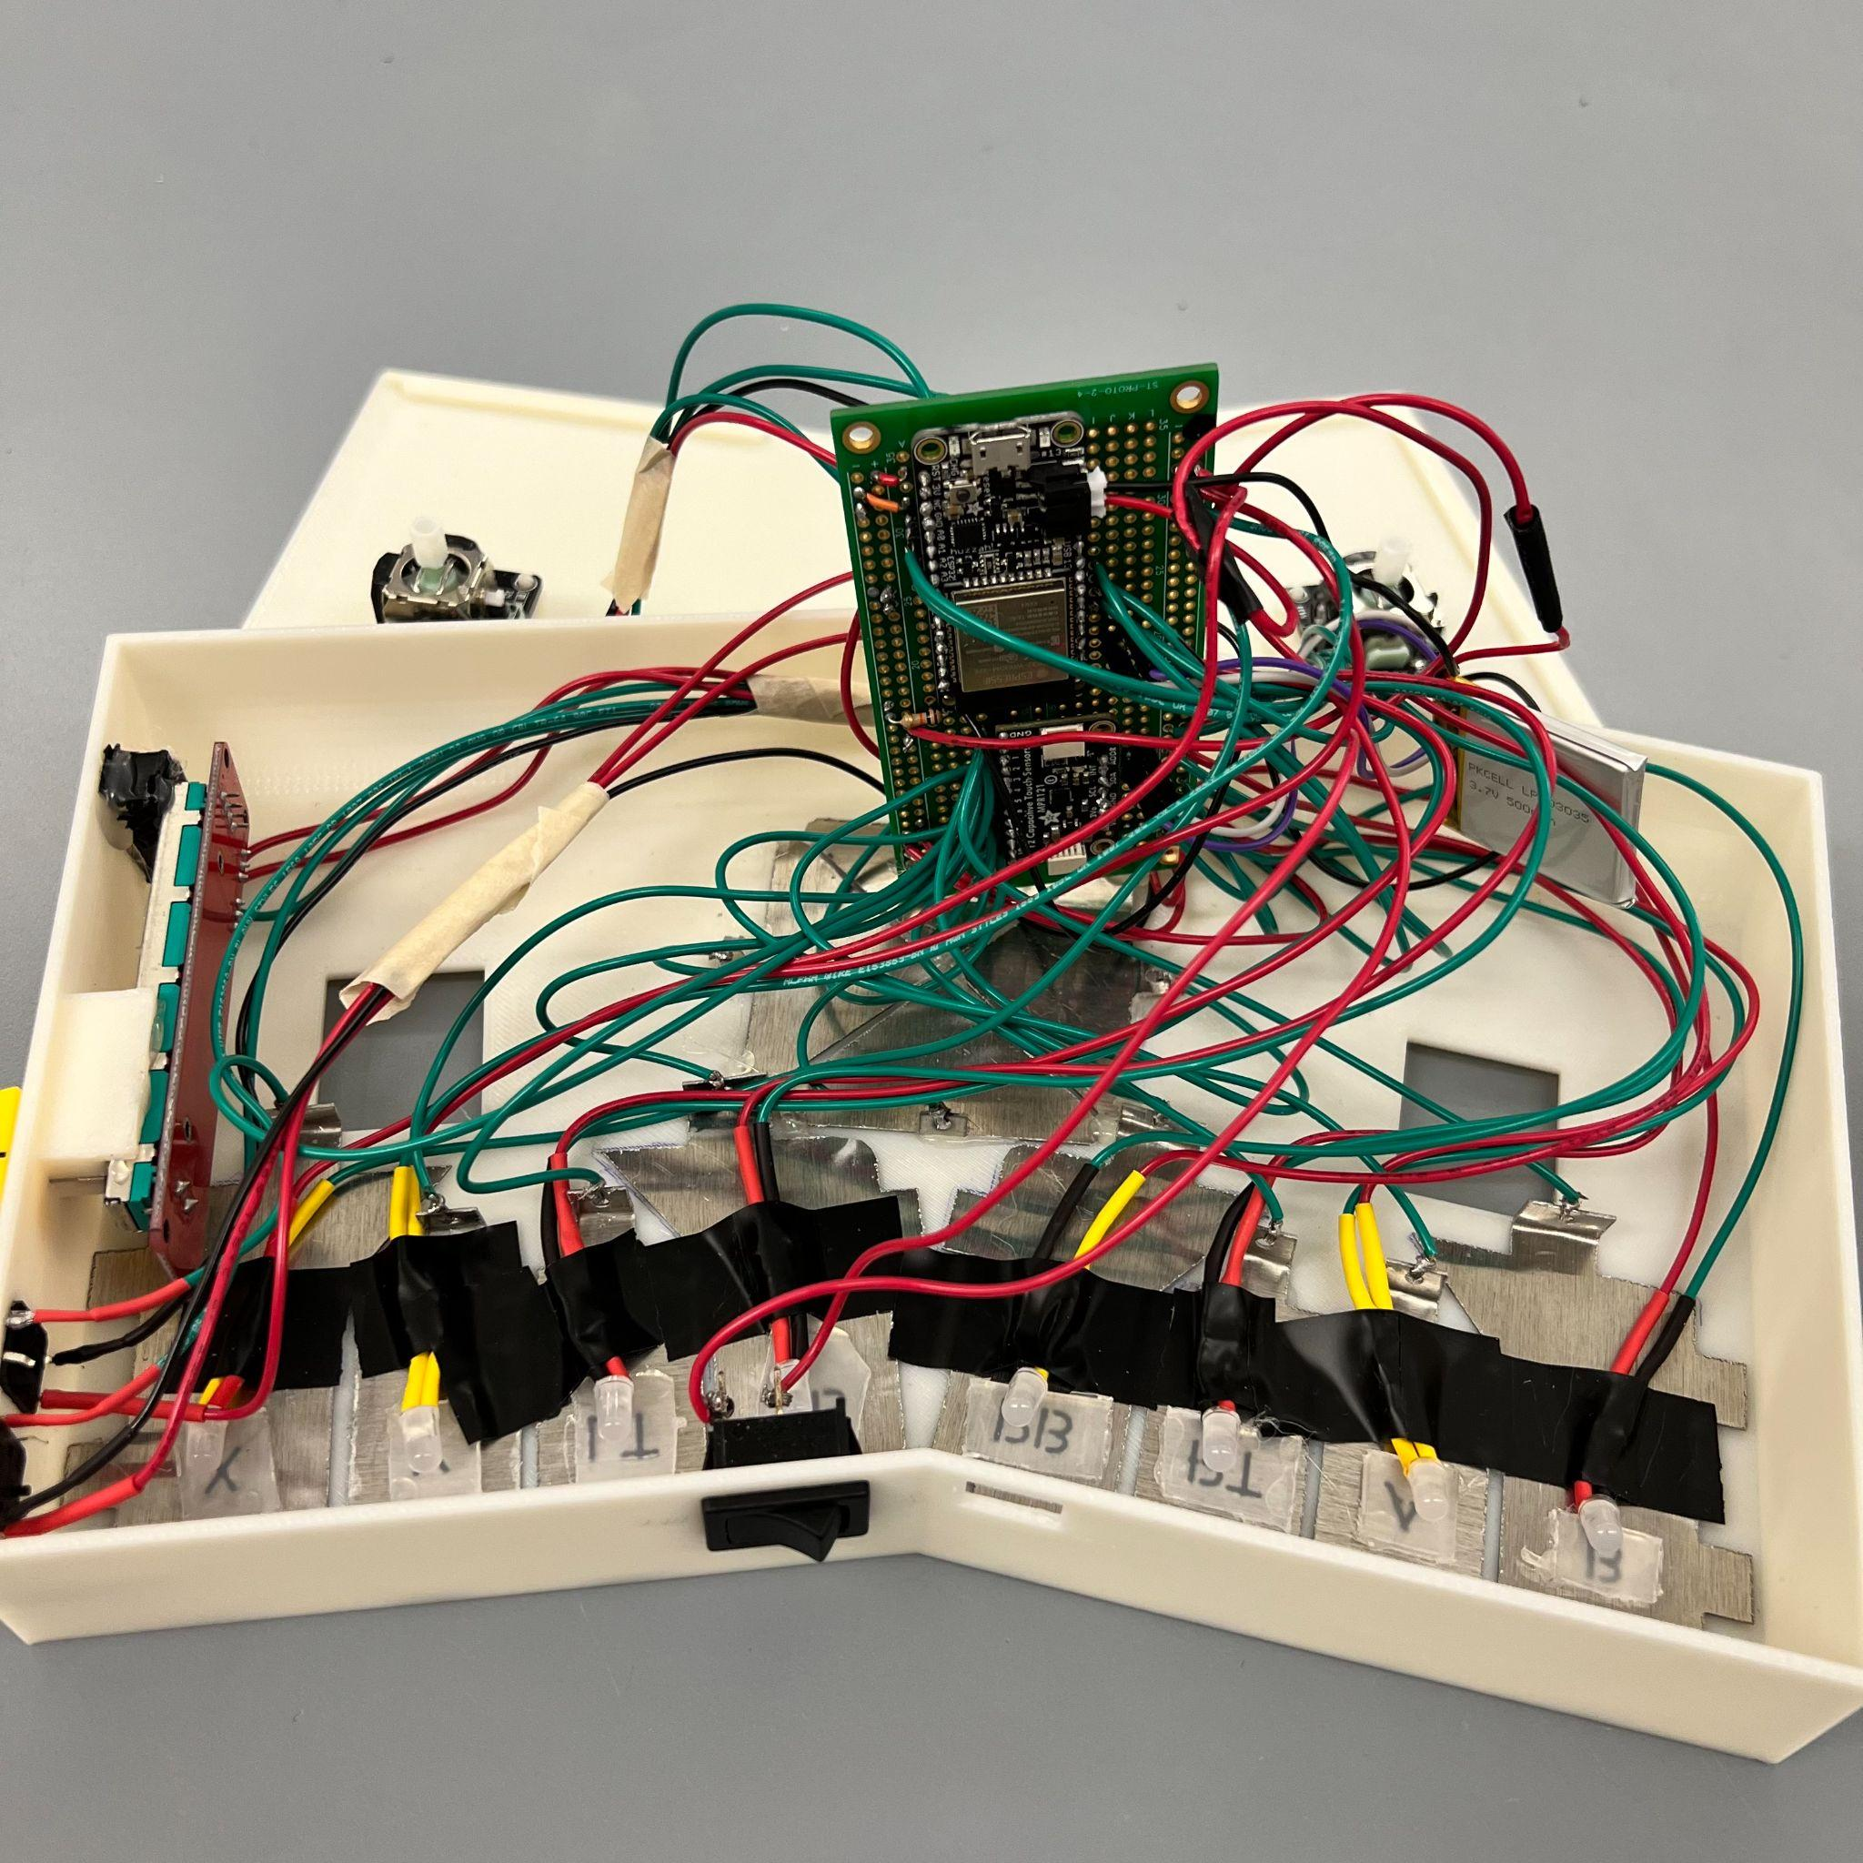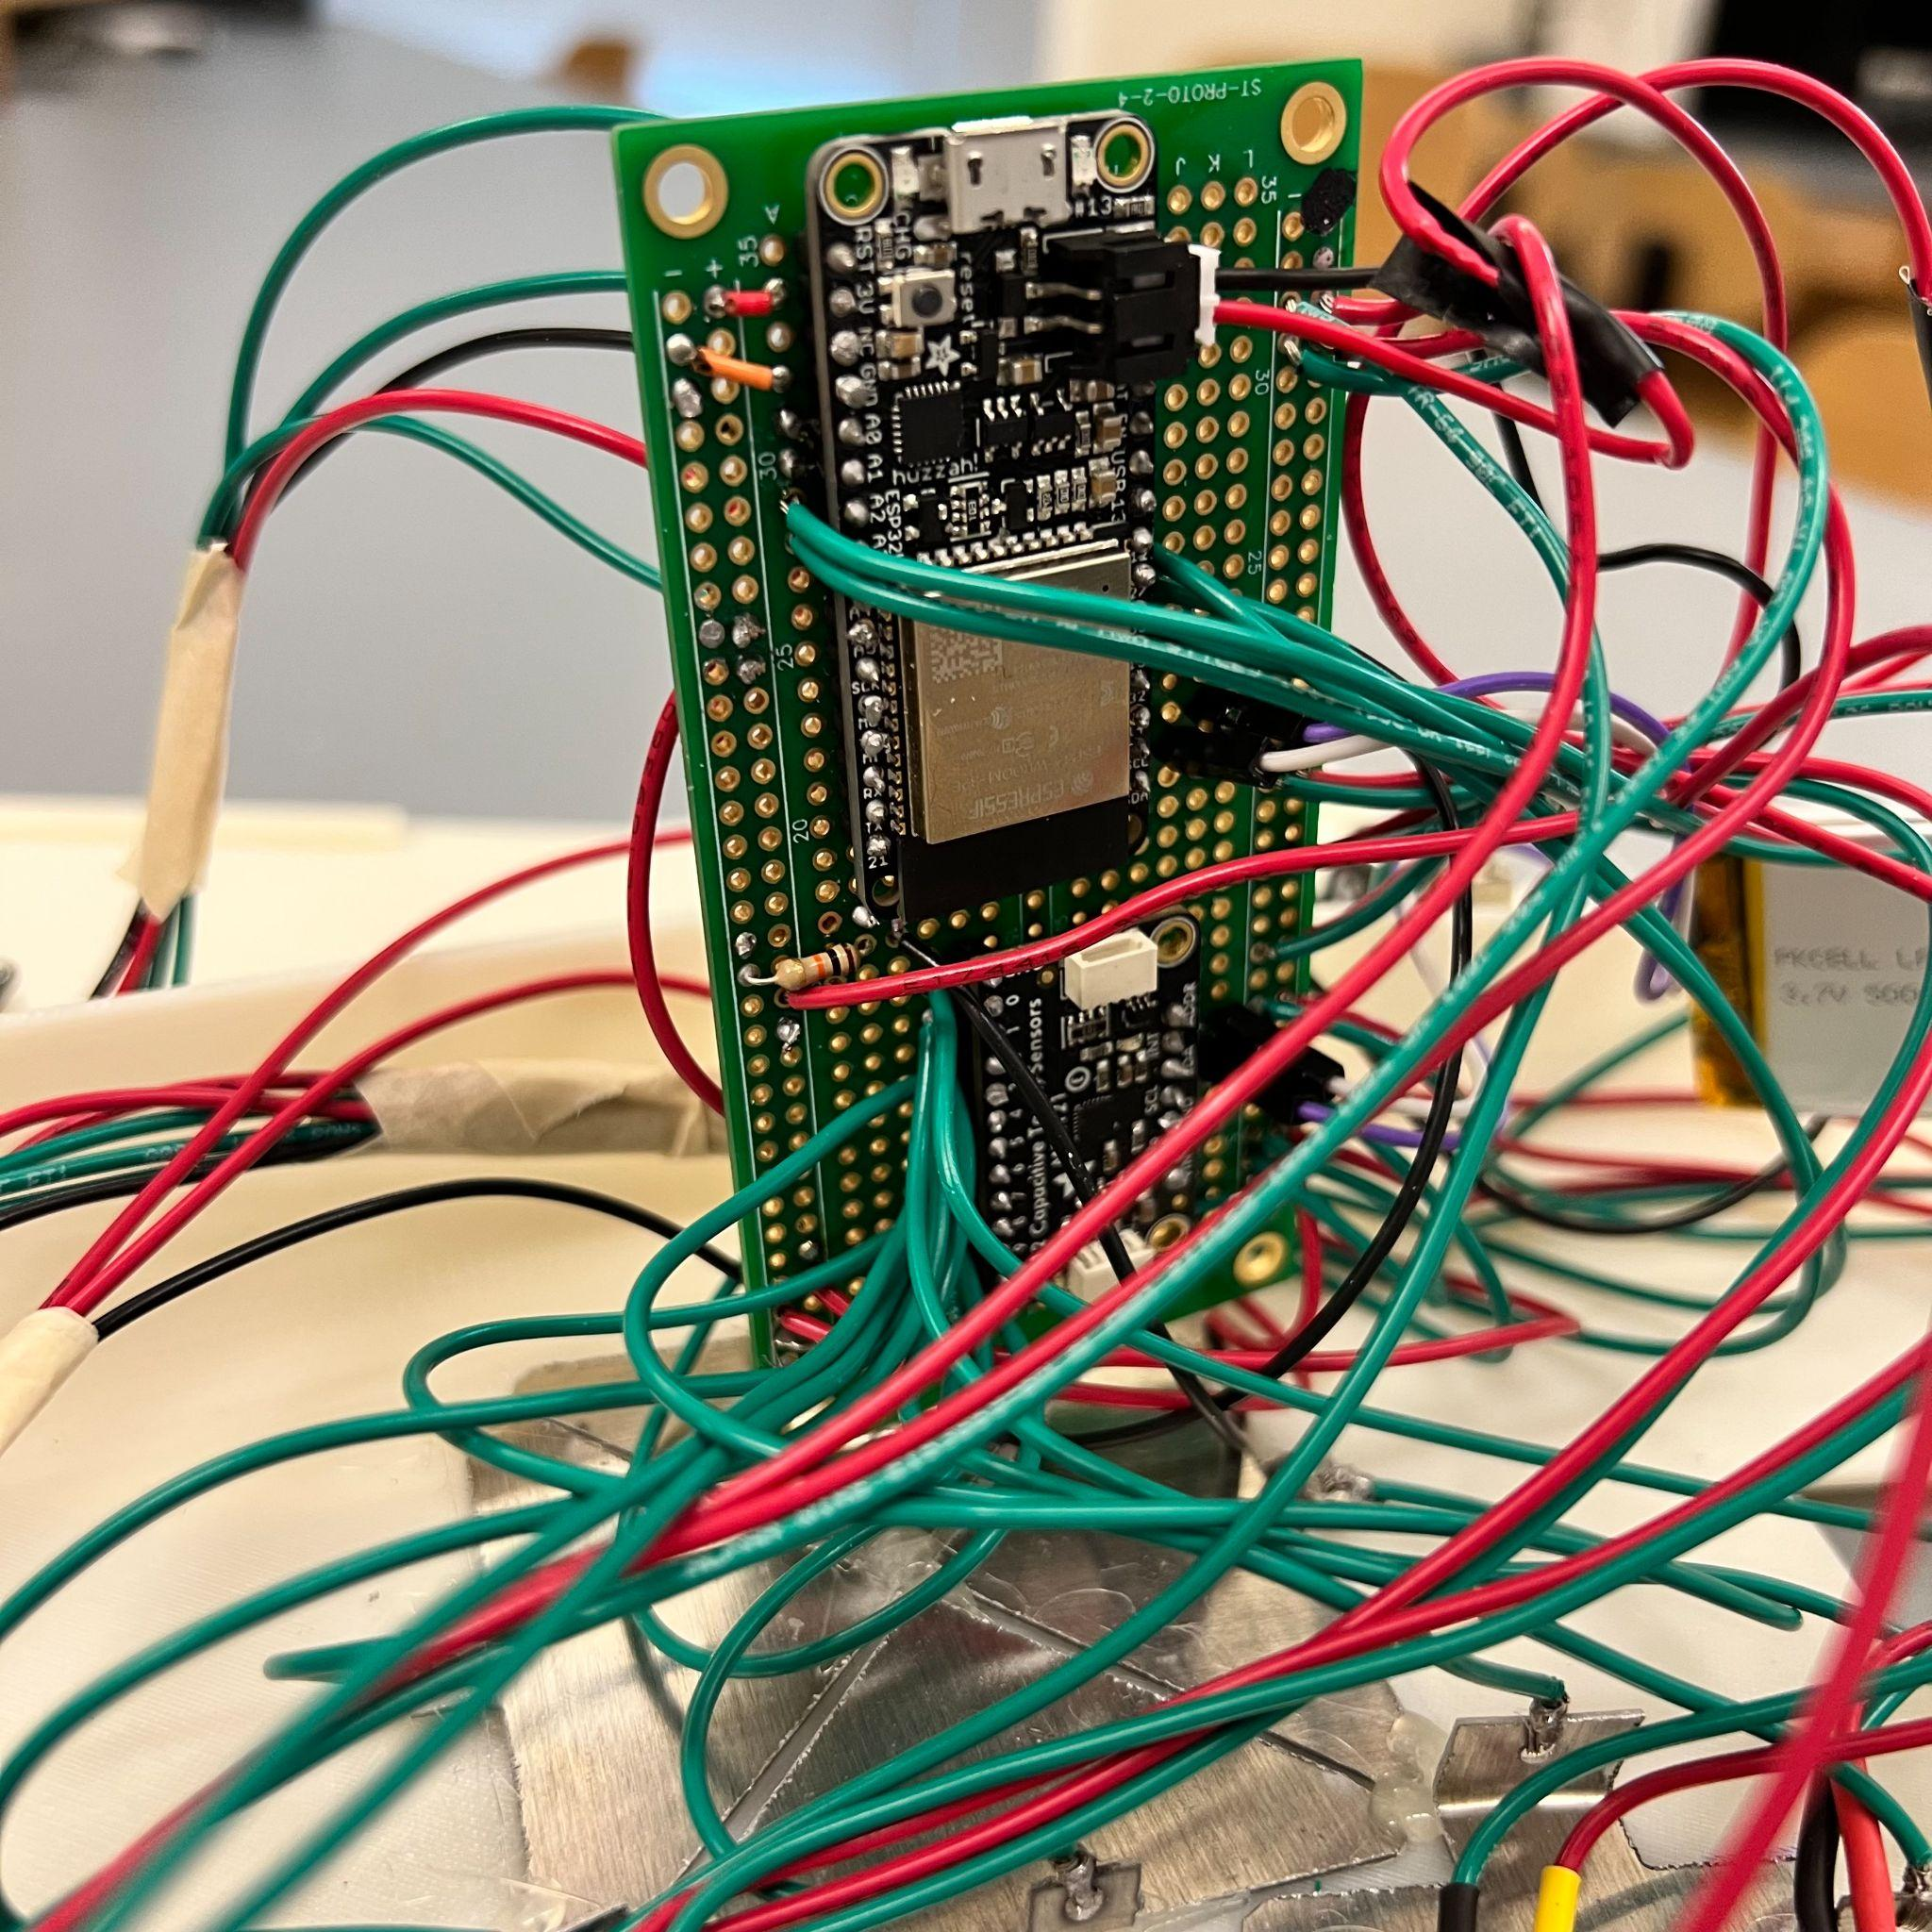

*Figure 4.1: Soldered electronic components*

The system hardware includes a rechargeable Lithium Ion Polymer battery (3.7V, 500mAh) connected to an ESP32 feather board microcontroller that powers the system in 3.3V. The rechargeable battery is wired to an On/Off switch that can be used by the customer to power the controller. All electronic parts will be wired and soldered on a protoboard.

The controller has several inputs, such as two joysticks, each with a 5V input pin, a ground input pin, an X-axis analog output, a Y-axis analog output, and an SW push button digital output. In addition, the controller uses an Adafruit 12-Key Capacitive Touch Sensor Breakout MPR121 chip to read inputs from twelve capacitive touch buttons made from aluminum sheets.

The system also includes Diffused 5mm Slow Fade Flashing RGB LEDs, each one controlled by a corresponding capacitive touch button. The colors of the LEDs will slowly change, and the brightness level can be controlled by the 10K logarithmic potentiometer slider.

***4.1.1 Physics of Touch Capacitive Board (MPR121)***

The MPR121 is a versatile and reliable touch sensor controller that supports up to 12 touch inputs. It operates at a voltage range of 1.71V to 3.6V, with a typical operating current of 29µA and a maximum operating current of 90µA (with all 12 electrodes active). The MPR121 is a capacitive touch sensor controller that works based on the principles of capacitance.

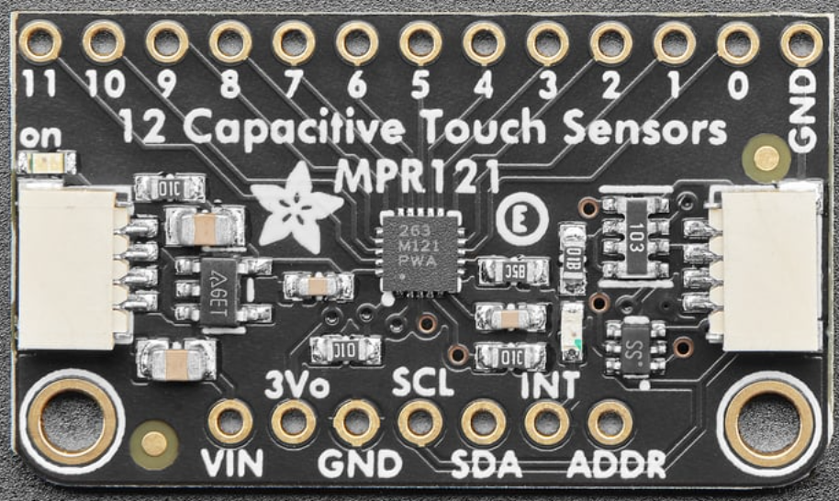

*Figure 4.2: Adafruit 12-Key Capacitive Touch Sensor Breakout MPR121 chip*

Capacitance is a property of a system of conductors and insulators that can store electrical charge. It is measured in farads (F) and is proportional to the amount of electric charge stored per unit of voltage. The electrode capacitance range is from 5pF to 50pF, and the electrode input impedance is 100 MΩ.

The MPR121 uses mutual capacitance sensing to detect touch events, where a voltage is applied to one sensing pad and the other sensing pads are used as the ground. A finger, which is conductive, changes the capacitance between them, which is detected by the MPR121 and interpreted as a touch event. Figure 4.2 shows that touch and release status is detected when the voltage output crosses the setting threshold.

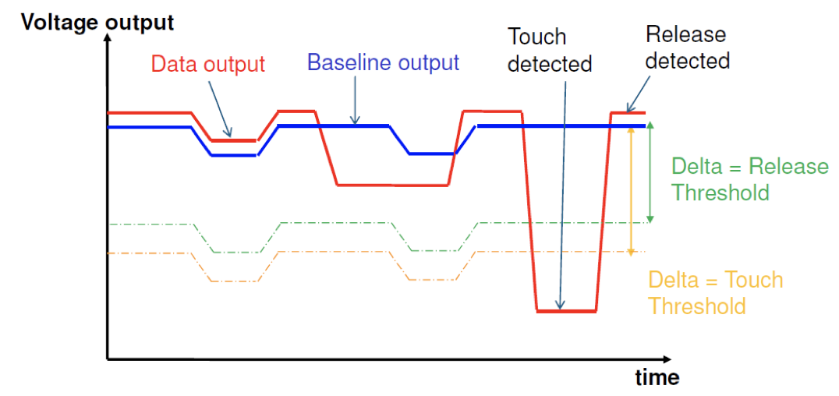

*Figure 4.3: MPR121 Touch and Release Detection* (<https://www.sparkfun.com/datasheets/Components/MPR121.pdf>)

The MPR121 employs various signal processing techniques to improve touch sensing accuracy and reliability. These techniques include baseline tracking, filtering, and noise suppression. Baseline tracking measures the capacitance of the sensing pads in the absence of touch events to adjust the sensitivity of touch sensing. Filtering techniques remove noise and interference from capacitance measurements.

***4.1.2 LEDs and Potentiometer Wiring***

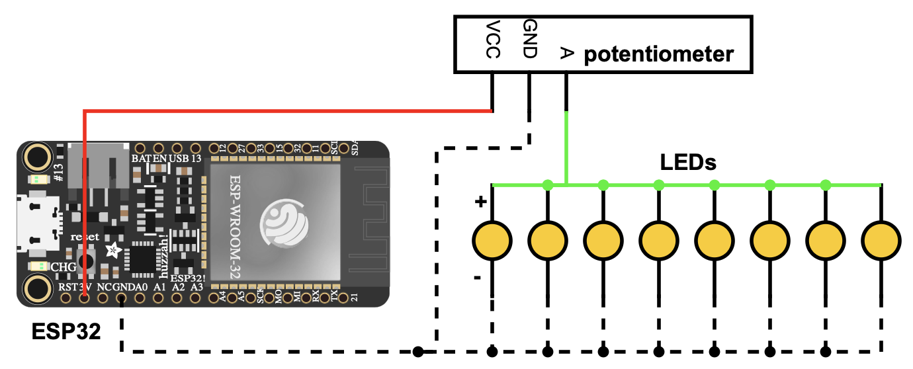

*Figure 4.4: LEDs and Potentiometer Wiring Schematic*

​​The E-Remote features LED lights that are used to indicate various controller functions and to provide visual feedback to the user. These LEDs are connected parallel to one another and are designed to be adjusted in brightness using a 10K ohm logarithmic potentiometer slider. The slider is connected to the OTA pin on the potentiometer, which changes resistance based on the slider position. The positive end of the LED is also connected to this OTA pin.

It is important to note that the negative end of the LEDs must be connected to ground. Additionally, the VCC pin on the potentiometer should be connected to the 3.3V pin on the ESP32 microcontroller. The Slow Fade Programmed LEDs are powered with 3.3V and are very sensitive to resistance. If resistance in each LED wiring is different, the color cycle does not match and the LEDs will be off. Therefore, it is critical to ensure that all wiring is of the same length and thickness to maintain consistent resistance. Any variance in wire length or thickness will cause a change in resistance, which will affect the LED color cycle.

To prevent any potential issues, it is recommended to use high-quality wires and to measure and cut all wires to the same length before connecting them to the LEDs and potentiometer. This will ensure that the resistance in each wire is consistent, resulting in an even and consistent color cycle for the LEDs.

* 1. ***Software***

***4.2.1 Libraries***

E-Remote is programmed using the Arduino IDE for its compatibility with the Adafruit HUZZAH32 ESP32 Feather board and access to the two driving libraries, Adafruit_MPR121 and ESP32-BLE-Gamepad. These two libraries are essential to the E-Remote program and implement the numerous functionalities needed for E-Remote to act as a game controller.

The Adafruit_MPR121 library is used to communicate with the MPR121 Capacitive touch board. The Adafruit_MPR121 object needs to be constructed and run its begin function, but its main use is the MPR121.touched() function which returns an uint16_t value representing the state of all twelve touch buttons. This value is then bit shifted by an amount representing the pin whose state the program wants to check and stored in a boolean value.

ESP32-BLE-Gamepad is the heart of the program as it takes the E-Remote and turns it into a video game controller. The first thing it does is enable the ESP32-WROOM-32E chip and allow the ESP to connect to the computer via Bluetooth. Second, it registers as a Bluetooth game controller so it can be properly recognized by the computer. Finally, it takes user inputs and properly converts them to the game action signal (A button to A action, left joystick to move, etc.).

***4.2.2 The Program***

Since the ESP is programmed with the Arduino IDE, the code is written in the C++ programming language. The program follows the basic Arduino programming structure of the Setup and Loop blocks. The Setup loop is used for initialization. It declares input pins for the physical buttons, starts the MPR121 chip, and most importantly, sets the configurations for the ESP32-BLE-Gamepad so there are no extraneous controls added.

The Loop will cycle through every user input and check its current state, and send its corresponding signal to the computer. If the input is a button (physical or touch), the program will check its current state against its previous state and will only send an updated signal if the state has changed, preventing extraneous repeat signals from being sent. It is important to note that although the state storage arrays and library variables are global variables, this is normal for Arduino-style code since there is no singular Main function to both declare and use variables and the loop and set-up blocks cannot access each other's variables. For the joystick inputs, the program will average one hundred values for each joystick and then either send a rest value if the average falls within the rest range or map them from the analog range of 0-4095 to the game joystick range of 0-32767. The rest range is determined on an axis-by-axis basis and is essential to proper mapping since the analog value of an axis at rest will fluctuate and could inadvertently cause movement where none is intended. In some instances, the controls are inverted by flipping the mapping (4095 mapped to 0 instead of 32767). This only depends on how the joysticks are wired and guarantees that up is always up, left is always left, etc.

Setup{  
 MPR121 Begin  
 Physical Button Pins = Input  
 Set Gamepad Configurations  
}  
Loop{  
 Poll Inputs  
 If Button{  
 Check previous state and send Button Signal if changed

If Joystick{  
 Average 100 reads  
 If Average in Rest Range: send Rest Val  
 Else: Map 0-4095 -> 0-32767  
 }  
 Send Joystick Signal  
}

* 1. ***Mechanical***

***4.3.1 Joysticks***

Each of the two palm joysticks of the E-Remote is implemented with two joystick breakout modules (thumbsticks) and a connector which links rods of thumbsticks. A thumbstick moves as a spheroid joint hence it can move along the x and y axis as well as rotate in 360°. Since our design is to allow users to hover the joystick over the casing, palm joysticks would be able to move parallel to the top plane of the casing. To make this happen, one thumbstick is placed inside the casing, and the other is attached to the bottom of the palm controller. A tiny - 0.3 inch height - connector is used to connect two parts, and it also allows users to easily replace palm controllers with a different size given from a manufacturer.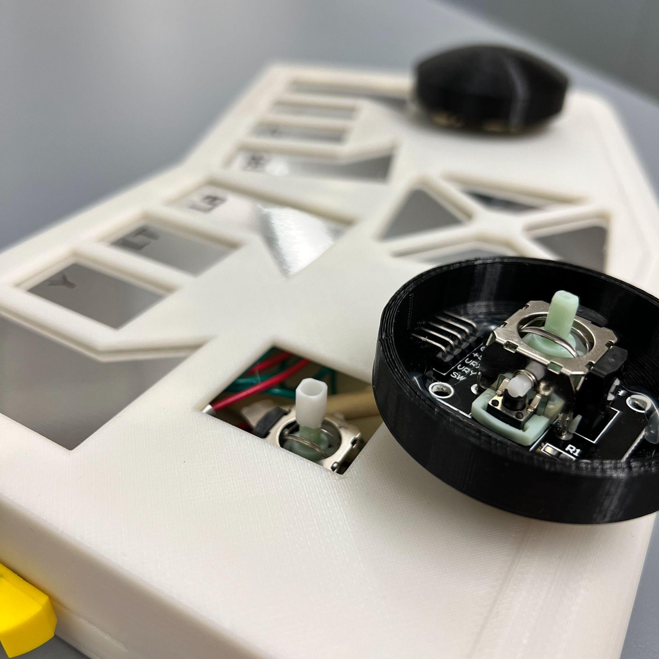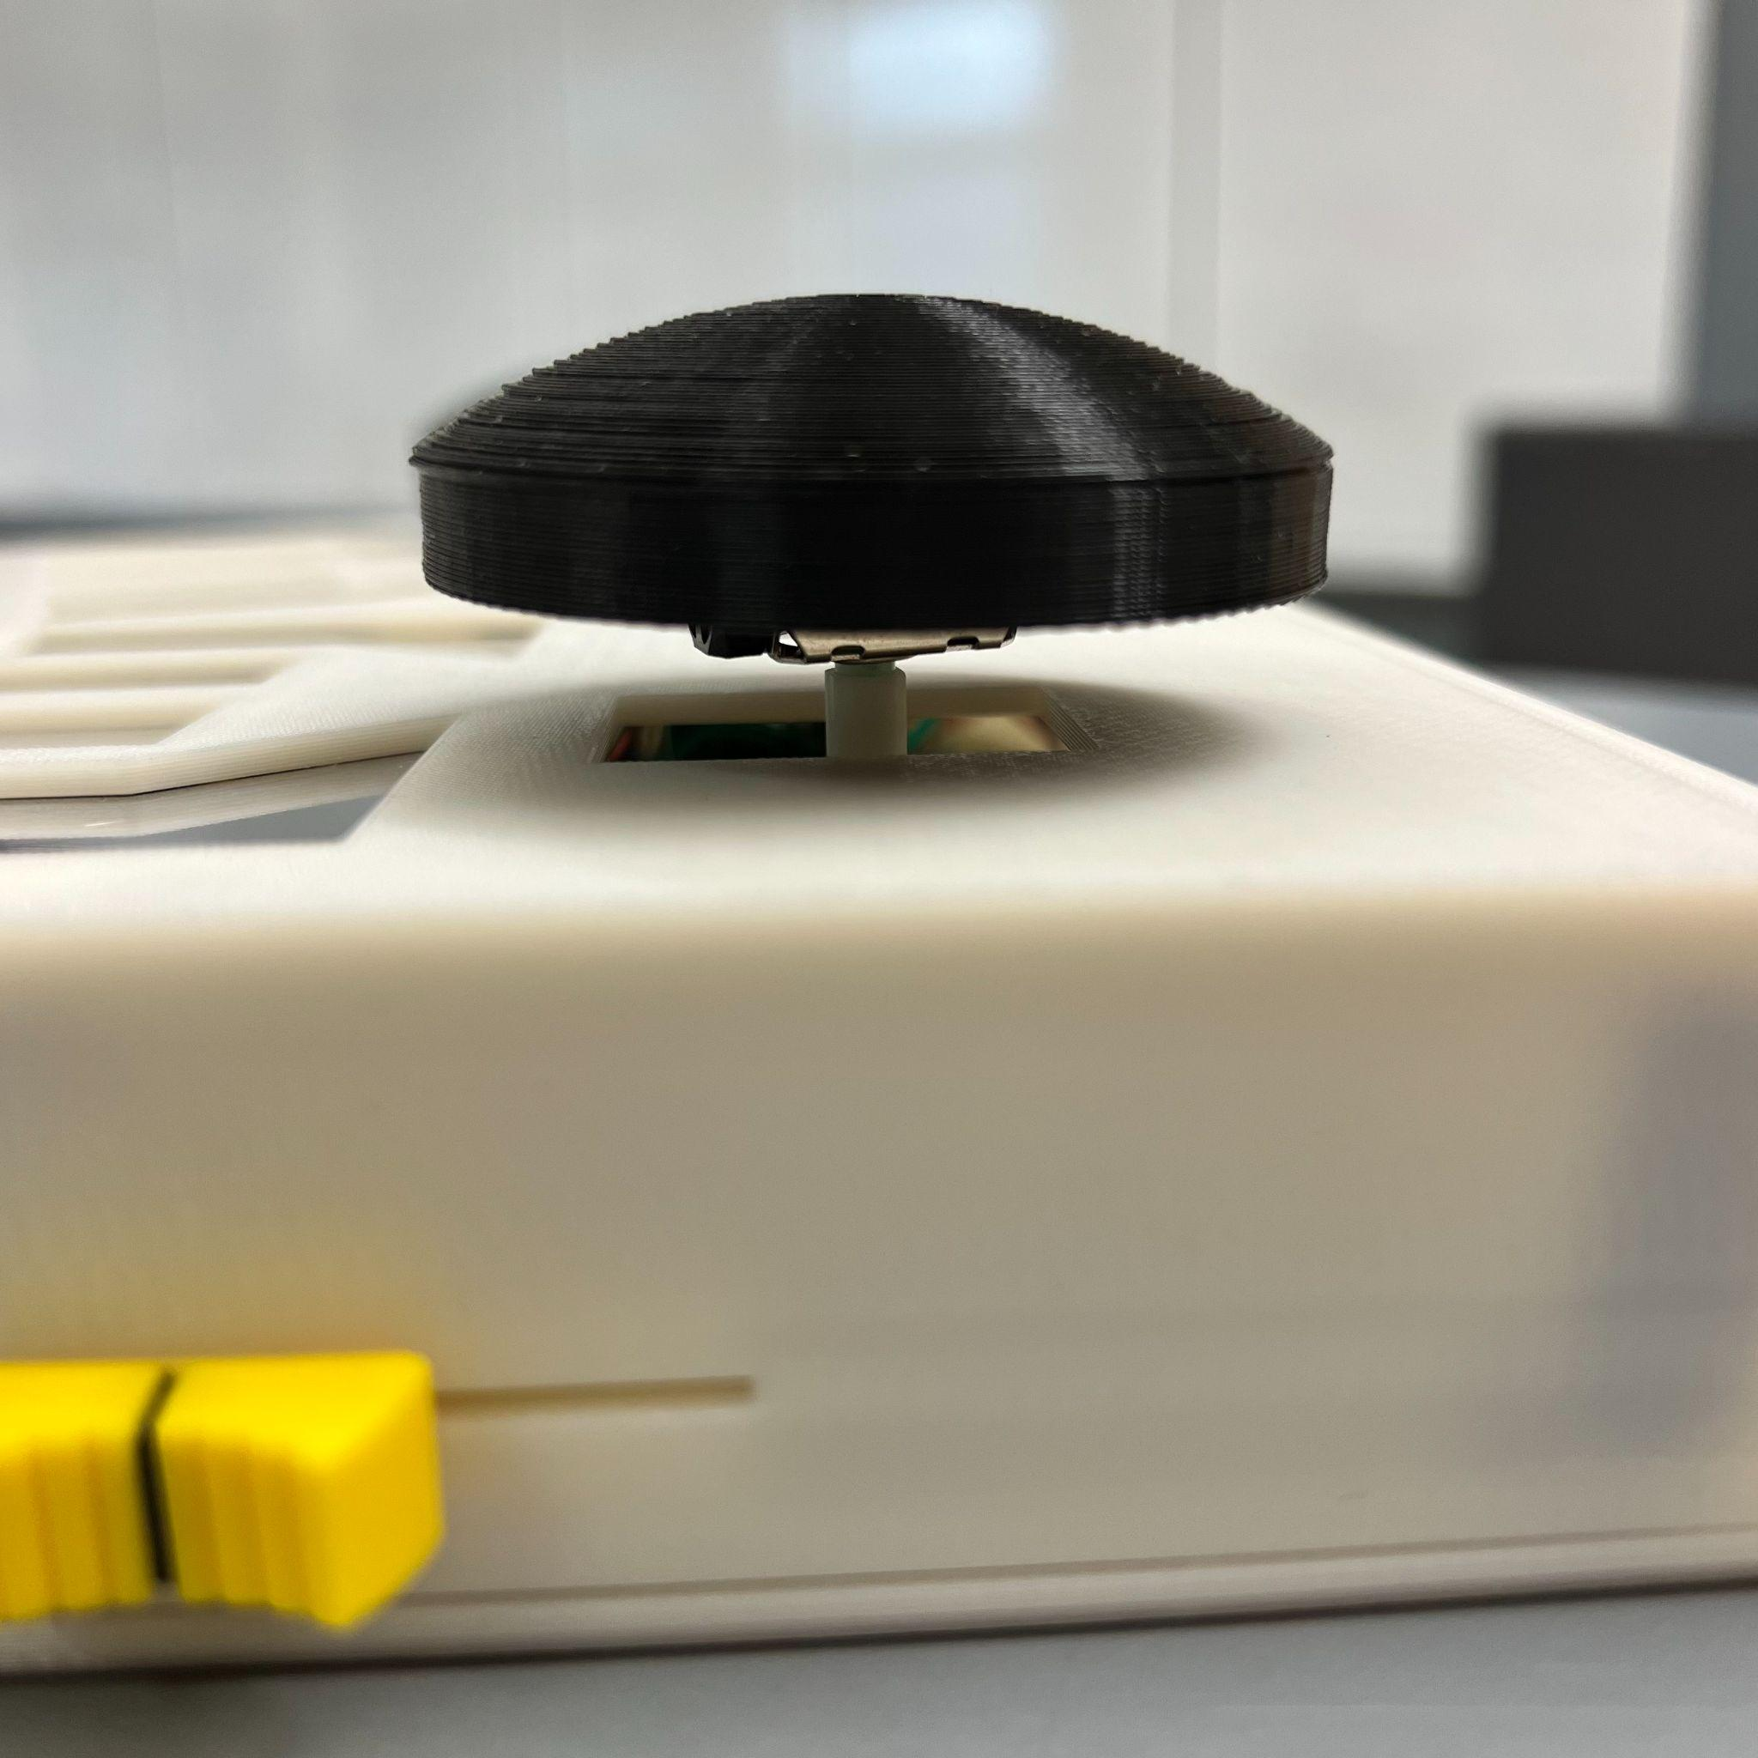

*Figure 4.5: E-Remote Joysticks*

***4.3.2 3D Printed Casing***

The casing and palm joysticks of the E-Remote are printed with the Stratasys F370 3D printer, which has an accuracy of +/- 0.200 mm. PLA (Polylactic acid) filament was chosen in order to reduce the cost of printing as well as to obtain a higher strength and stiffness than both ABS and nylon. Moreover, it is environmentally friendly material as the material was made from renewable resources. Thickness of the casing was set to 0.08 inch which is a minimum thickness that will not cause wobbling and bending of the controller while playing a game.

# Relevant Engineering Standards

This section of the report will discuss the specific engineering standards that were considered during the design and development of the controller, and how they were implemented to ensure that the final product is safe, reliable, and accessible to its intended users. By adhering to these standards, the controller will not only meet the needs of those with hand arthritis, but also provide a high-quality gaming experience for all users.

1. ISO 9241-11: This standard provides guidance on the design of interactive systems and can be relevant for ensuring that the video game controller is easy to use and ergonomic for individuals with hand arthritis.
2. IEC 60601-1-2: This standard outlines the requirements for medical electrical equipment to ensure electromagnetic compatibility and can be relevant for ensuring that the controller does not interfere with other medical equipment.
3. ANSI/UL 94: This standard outlines the requirements for testing the flammability of plastic materials and can be relevant for ensuring that the 3D printed controller is safe for use.
4. IEEE 802.15.4: This standard outlines the requirements for low-rate wireless personal area networks (LR-WPANs) and can be relevant for ensuring that the controller's Bluetooth connectivity is reliable.
5. Section 508 of the Rehabilitation Act: This law requires that federal agencies make their electronic and information technology accessible to individuals with disabilities. While this law may not apply directly to the project, it can serve as a useful guideline for ensuring that your video game controller is accessible to individuals with hand arthritis.
6. ASTM F2057: This standard outlines the requirements for testing furniture tip-over stability and can be relevant for ensuring that the controller is stable and does not tip over.
7. EN 60950-1: This standard outlines the requirements for the safety of information technology equipment and can be relevant for ensuring that the controller is safe for use.
8. ASME Y14.5: This standard outlines the requirements for dimensioning and tolerancing, which can be relevant for ensuring that the 3D printed controller is manufactured to the appropriate specifications.
9. ISO 12100: This standard outlines the requirements for risk management for machinery and can be relevant for ensuring that your controller is safe for use.

# Cost Breakdown

The E-Remote was designed to be an affordable solution for individuals with hand arthritis to be able to enjoy playing video games. As such, we made every effort to keep costs low while still providing a quality product. The following is a cost breakdown for the E-Remote:

| E-Remote Cost Per Unit | | | | |
| --- | --- | --- | --- | --- |
| **Item** | **Description** | **Cost/Unit** | **Quantity** | **Total Cost** |
| 1 | Adafruit HUZZAH32 - ESP32 Feather Board | $19.95 | 1 | $19.95 |
| 2 | Adafruit MPR121 - 12 Key Capacitive Touch Sensor Breakout | $7.95 | 1 | $7.95 |
| 3 | Lithium Ion Polymer Battery | $7.95 | 1 | $7.95 |
| 4 | Diffused 5mm Slow Fade Flashing RGB LED - 10 pack | $4.95 | 1 | $4.95 |
| 5 | Joystick Breakout Module Game Controller | $1.30 | 2 | $2.60 |
| 6 | 2” x 4” Protoboard | $4.99 | 1 | $4.99 |
| 7 | 10K Linear Potentiometer Slider | $4.80 | 1 | $4.80 |
| 8 | Plain Aluminum Sheet in Silver | $14.63 | 0.5 | $7.32 |
| 9 | 3D Printer PLA Filament | $19.99 | 0.5 | $9.99 |
| Beta Version-Total Cost | | | | $70.50 |

# Appendices

*[Appendices include supplemental information for the User that would distract if included in the regular sections.*

## Appendix A - Specifications

Give these as a list or table. These should quantify the performance that the project provides, as it is built. Do not simply repeat functional requirements here. These are the final delivered specifications. These will usually map closely to the User’s requirements. **1 page, table format**

| Component | Specification |
| --- | --- |
| Case Dimensions | 10.7 inch x 6 inch x 2.5 inch |
| Joystick Dimensions | ⌀ 2.20 inch x 0.75 inch |
| Material | Polylactic acid |
| Weight | 15.15 oz (430g) |
| Power Supply | Rechargeable Lithium Ion Polymer Battery (3.7V, 500mAh)  24 hour runtime/charge |
| Input lag | < 120 ms |
| Bluetooth sync time | < 30s |
| Connection range | < 10 m (33 ft) |
| Cost | $70.50 |

## Appendix B – Team Information

Eunhye Kwon is a senior graduating from Boston University in Spring 2023 with a BS in electrical engineering. Eunhye has a special interest in control systems, renewable energy, and power distribution. With experience working on control systems at Kulicke and Soffa Inc. and energy distribution at National Grid, Eunhye has a well-rounded understanding of all aspects of electrical systems. Eunhye can be contacted by email: [ekwon23@bu.edu](mailto:ekwon23@bu.edu), or by phone: 484-682-9222.

Nicholas Gutierrez is a senior at Boston University graduating in Spring 2023 with a degree in Computer Engineering. Prior to attending Boston University, Nicholas had never taken a programming course and found his passion for programming after taking his first class. He has since had two consecutive internships with Amazon Web Services and has completed several personal projects. He has a special interest in algorithmic design and hopes to continue learning after graduation. He can be contacted by email: [nickgutz805@gmail.com](mailto:nickgutz805@gmail.com) or by phone: 615-557-3141

Seok Young Choi is a senior at Boston University graduating in Fall 2023. He is pursuing a degree in Computer Engineering (BS) and a minor in Mechanical Engineering. Seok Young has interest in computer architecture, digital design, as well as product design and development. While taking computer engineering courses for his major, he discovered his interest in mechanical engineering when he joined the Terrier Motorsports team and acquired knowledge of 3D modeling and mechanical design. Upon completion of his undergraduate studies, he intends to apply his experience and knowledge into practical applications. He can be contacted by email: [schoi11@bu.edu](mailto:schoi11@bu.edu), or by phone: 857-361-2236.

Yumin Lisa Wei is a senior at Boston University graduating in Spring of 2023 with a B.S. in Electrical Engineering. Yumin has an interest in circuit design/prototyping, fabrication of integrated circuits, and VLSI. While working at Signify (formerly Philips Lighting), she learned her love for building prototypes and debugging circuits while also leading a personal project on power savings. There she learned many technical skills required for soldering surface mount and through-hole PCBs. Upon the completion of her undergraduate studies, she intends to apply her knowledge into the semiconductor industry. She can be contacted by email: [ylisawei@bu.edu](mailto:ylisawei@bu.edu) or by phone: 857-222-1758.